Yishun Innova Junior College

H1 Geography

Suggested answer

Section A

Cluster 1 : Fieldwork

1 | A group of ten 18 year-old Geography students carried out an investigation to look into the transport needs of the elderly living in the Serangoon North neighbourhood. The elderly makes up 30% of the local population. Of the elderly residents, 60% were 65-74 years old, 35% were 75-84 years old and 5% were over 84 years old. Females make up 55% of the elderly residents.  The hypothesis of their investigation was :  “The majority of elderly residents in the Serangoon North neighbourhood find their transport needs adequately met”.  The students designed a survey questionnaire and carried out the survey on a Friday morning, between 10am to 12noon. They surveyed a total of 80 elderly people.  55 elderly are aged 65 to 74 years old, and  20 elderly are aged 75 to 84 years old.  5 elderly are aged above 84.  Resource 1 shows the location where the students will carry out the fieldwork..  Resource 2 shows the questionnaire the students used for their survey. Resource 3 shows selected results of the survey.

(a) | Explain whether the students’ hypothesis is suitable.  Indicative content :  The hypothesis is suitable  - at a suitable scale (the Serangoon North neighbourhood is accessible to students, ie, not a private property)  - researchable or measurable (survey/interview can be carried out)  - clearly defined variables (target audience and the neighbourhood for investigation are clearly defined)  It is also possible to suggest that it is not suitable  - The term ‘adequately met’ can be subjective. The phrase differs from the ‘most satisfied’, ‘satisfied’ used in the survey form.  Examiners’ comments :  - Now that majority knows that the above is the correct response, there are still a few who are not applying the context within the answer. Instead of saying that ‘the students can carry out an investigation to ascertain the hypothesis’, you should be saying that ‘the students are carrying out a survey to investigate whether the elderly residents in the Serangoon North estate find the transport needs are adequately met’.  - Some suggest that ‘majority’ is uncertain(?), when ‘majority’ should mean anything above 50%! |  | [4]
(b) | Suggest how the students could minimise two potential risks arising from undertaking the fieldwork in the location shown in Resource 1. |  | [4]
Indicative content :
- Danger of inclement weather (1), hence need to check on weather forecast and be properly attired (fear of heat stroke and dehydration) and bring umbrella (in case of rain) (1) (as long as the study is outdoor, there is a cause to worry about the weather and issue of dehydration)
- Fear of passing vehicles and hence do not work too close to the road, be wary of PMAs passing by the location. (1) Preferably work in pairs so that members can look out for each other) (1)
- Keep a lookout for oncoming cars, especially when working near the road bends since there is a risk of the vehicles skidding at the road bends. (either this point or the above. Try not to focus on traffic issue in both your risks, as it can seem repetitive)

Examiners’ comments
- Provide a solution to the identified problem, and not just identified the risk.
- It is easy to suggest a change of location. However, the intention is to overcome the risks given the identified location. Hence should not merely be suggesting a change of location. Moreover the bus stop provides good shelter. And the presence of the students should not be seen as posing any disturbance to the commuters since the bus stop is big enough to accommodate the 2 students.

(c) | Suggest two reasons why the students categorised the age groups as shown in Resources 2 and 3. |  | [4]
Indicative content
- Because of the given profile of the community (as seen in the preamble), hence will follow the given profile identified in secondary research
- Different age group is likely to have different needs, hence need to further divide the elderly into young old (65 to 74 years old), mid old (75 to 84 years old) and more than 84 (old old)
Examiners’ comments
- The choice of the age category has little to do with the sensitivity of revealing the actual age. Please read the question carefully. Though I do give 1m if you have mentioned that respondents may likely not mind as much in choosing the age range than revealing their exact age.

(d) | Suggest two possible issues related to research ethics for this investigation.  Indicative content  - Asking about biodata of the elderly can be sensitive (1), hence should not prompt further if the elderly are reluctant to answer the question (1). [Please note that this applies to all question on biodata and not just the age]  - A study on transport needs of the elderly can have implications on the policy measures, hence the students must handle the results findings carefully. (1) The results should not be kept confidential and not be released, in case of falling into the wrong hands. (1) There should also not be a manipulation of research findings and ensure authenticity of the results.  - Alternatively, can mention that the research should take into consideration the privacy of the residents of the neighbourhoods. The students’ investigation should not be seen as disrupting the daily on-going activities of the residents.  Examiners’ comments  - You should have realised by now that your answers are point marked. Hence avoid giving 1-liner answer, without a valid explanation for your answer.  - The biggest issue here is that candidates do not understand ‘research ethics’. |  | [4]
(e) | Explain the best way the students can present the data they collected from the questionnaire in Resource 3.  Indicative content  - May either choose to use radar chart or bar graph. Explain the use of bar graph making reference to what each bar will represent. In this case the different age group (colour coded or shaded for easier comparison across the different questions). Also mentioned what are the x-axis (transport needs) and y-axis (the total number of elderly), the key, the title…  - Hence ideally, you should have sketch the bar graph to show that it is ‘more visually pleasing and is easy for comparison’ across age groups and across different transport needs.  Examiners’ comments  I did not accept pie as an option since the total number in each needs are ot equivalent. So even if you can draw multiple pies, it is just not possible to compare across the different needs. |  | [4]
(f) | The students concluded that the transport needs of the majority of elderly in the Serangoon North neighbourhood are adequately met.  Evaluate the validity of their conclusions. |  | [10]
Indicative content
Based on the findings in Resource 3, it is not easy to draw conclusion that the 80 elderly are satisfied with the transport needs. In terms of public transport (bus, MRT etc), 38 out of the 80 elderly have chosen ‘most satisfied’. However, it is not easy to conclude that the majority or at least the 50% majority are satisfied and mostly satisfied, without the results for the other options. For some of the needs, such as ‘availability of transport options in times of emergency’, the total number who are ‘mostly satisfied’ are even fewer at 10 out of 80. In fact, a significant number cannot provide a definitive response, hence leading to ‘no data for the particular needs. Therefore no conclusive conclusion can be made based on the available information in Resource 3.

It is also too myopic to look at just the available needs such as public transport and other forms of transport (ride sharing, car-sharing scheme) to draw conclusion. Resource 2 suggests that there is a focus on public transport needs in the study. In fact, elderly also rely on taxi of grab transport service. Such forms of needs are not assessed in the survey. Hence Resource 2 should consider other questions which include other modes of public transports. There can in fact be elderly who drive or use the private transport and their needs can differ vastly. Hence either the survey questions can be expanded to include the other private transport needs or the hypothesis can clarify that this is a study only on ‘public transport needs’.

The survey is only written in English language and it may mean that the students either need to translate for certain elderly or the non-English speaking elderly may not be included in the investigation. This may affect the authenticity of the final results, since certain groups of elderly may be left out of the study.

In addition, for a better understanding of transport needs, there is a need to conduct open ended interview to find out about needs of the elderly. By stationing the fieldwork in the vicinity of the bus stop (Resource 1), there is tendency to survey only respondents who use the public transport are surveyed, and this can skew the results of the survey.

It is not helpful that the 80 elderly surveyed is not representative of the age profile of the estate. (the 80 elderly surveyed are representative of the age profile in the neighbourhood). Moreover it is not sure if the elderly surveyed are representative of the gender profile in the estate.

 | 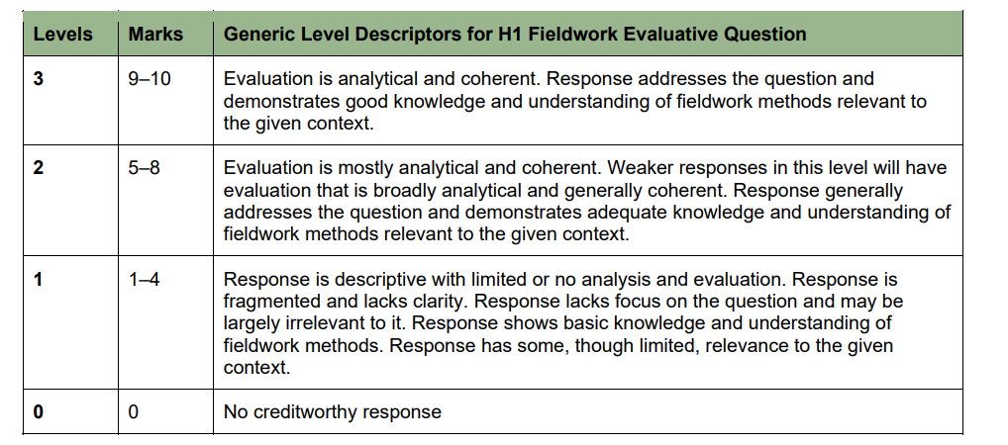
Section B

Cluster 1 : Sustainable Future and Climate Change

2 | Creative industry parks ( ) located on former industrial sites in Beijing's urban area. Amongst the creative spaces, 798 Art District is one of the largest Chinese contemporary art community developed on the site of a previous military industrial complex, it acted as a role model in the transformation of the Beijing Municipality from a national industrial city to an emerging global creative city. and is located in the northeast corner of Beijing. It is also called the Dashanzi Art. In 2006 the industrial site was designated as one of 30 officially recognized industrial districts for cultural and creative industries. 798 has also evolved into the third most visited destination in Beijing, after the Forbidden City and the Great iept .  Resource 4A and 4B show the photographs of the Art District before and after reimaging. Resource 5 shows a map of Beijing. Resource 6 shows the employment structure of cultural and creative industries in Beijing. Resource 7 is an interview extract with an artist who arrived at 798 District before 2005.
(a)  (b) | With reference to Resource 4, suggest why reimaging was necessary.  Indicative content  - Socially, the old buildings are not pleasant and required new code of paint etc to rejuvenate the image. (1) Hence the former activities which may no longer be suitable for the location should be replaced with new activities more acceptable by the residents. (1) In this case, the old industries are replaced by Art activities, café etc. This will help to inject energy and life to the place, through the more vibrant activities.  - Environmentally, old buildings will start to decay as they become dilapidated, if not occupied or maintained. (1) Through the introduction of the new tenants into the area, there can be refurbishment of the old buildings such as new coat of paint, hence helping to maintain and upkeep the pace. This is a way of conserving the building is also sustainable use of the original building, since it has given new meanings to the original façade. (1)  - Economically, the new activities will generate income tax receipt for the local government. (1) The rise in visitorship or tourism is a welcomed move for a declining area. (1)  Describe the spatial distribution of the creative industry parks in Beijing, using Resource 1. |  | [4]  [4]
Indicative content
- All creative industry parks are dispersed outside the old city, mostly outside the inner urban with only. (1) 2 of the 10 found within the inner urban (1)
- Concentration of creative industry parks in the North and North East of Beijing. (1) The two exceptions, with one in North and one in the West. None found in the South
- Majority are found along the main road or the railway. (1)
- For the majority, their locations also coincide with the factory and warehouse. (1)

Examiners comments
- Quite a few did not read the question carefully and were just describing the map of Beijing and its various land uses.
- The key to map reading is to read the key, so that the terms mentioned in the key are used appropriately.

(c) | With reference to Resource 2, explain how changes in employment of the creative and cultural sector between 2007 and 2012 may affect economic development in Beijing. |  | [4]
Indicative content
- Increase in income with the employment in the creative and cultural sector. Quote data on the increase. (1) [Many did not proceed beyond this. Do note that the question expects an explanation]
- There can be indirect impact such as the tourism industry (after all, the 798 Art District is the 3rd most visited place in Beijing. With urban regeneration and development, creative industries can play a vital role in urban regeneration, transforming underutilised areas into vibrant cultural hubs. This can attract tourism, investment, and talent, further boosting economic growth. (1)
- Service sector generate more income ideal for the development of the country, reducing reliance on traditional industries and potentially making the economy more resilient to economic downturns in specific sectors. (1)
- The creative industry often drives innovation, as it encompasses fields like design, media, technology, and the arts. This can lead to the development of new products, services, and business models, enhancing the country's global competitiveness. (1) Hence attracting foreign investment especially in the art-related or cultural related industry.
- However, the increase of 3% from 2007 to 2012 may be insignificant. (1) Only less than 3% in the 5 years period, may not have much significant impact? The growth of creative jobs may also present challenges, such as income inequality, precarious employment conditions, and the displacement of traditional industries and communities. It may also lead to increased competition for resources like real estate, driving up costs in certain areas. (1)
- The increase could also be at the expanse of other sectors, such as the blue collar workers, who may have lost their jobs due to structural changes in the economy. (1)

Examiners’ comments
- To answer this question well, there is a need to explain the direct and indirect impact that the art and cultural sector can have on Beijing. The economic impact can also be driven by influex of foreign investment. Moreover, many failed to see that there can be negative impact to the reimaging. It is also suggested in Resource 7 (the final Resource), that there can be inflationary pressure and some arts workers (especially the smaller players in the industry) may be pushed out of the District as they cannot compete with the bigger more established players in the industry.

(d) | With reference to Resource 5 and 6, explain the role of the Beijing government in shaping the reimaging strategies? |  | [4]
Indicative content
1. Policy Initiatives and Urban Planning
- The Beijing government implemented various policy initiatives and urban planning strategies to promote cultural and creative industries. This included designating specific areas, such as the 798 Art District, as official zones for cultural and creative development. By doing so, the government facilitated the establishment of art galleries, studios, and cultural institutions, fostering a vibrant creative community.

2. Industrial Relocation and Environmental Goals
- In preparation for the 2008 Beijing Olympics and in line with the 'Green Beijing Olympic Games' initiative, the government prioritized environmental improvements. This led to the relocation of many industrial enterprises from the city center to the outskirts or other regions. As a result, former industrial areas were repurposed for creative and cultural uses, contributing to the reimagining of these spaces as hubs of innovation and artistic expression.

3. Economic and Cultural Investment
- The Beijing government supported the creative sector through financial incentives, grants, and investments in infrastructure. This support helped attract both local and international artists, designers, and entrepreneurs to the city, boosting the creative economy and enhancing Beijing's cultural capital. The government's investment in cultural infrastructure also played a role in promoting tourism and city branding.

4. Regulation and Governance
- The government established regulations and governance structures to manage the development of creative zones. This included zoning laws, tax incentives, and guidelines for the use of space. By regulating the development of these areas, the government ensured that the growth of the creative industries aligned with broader urban development goals and maintained a balance between commercialization and cultural preservation.

5. Promotion of Cultural Openness
- The Beijing government actively promoted the city's cultural openness and diversity, leveraging the creative sector as a symbol of modernity and progress. This involved supporting events, exhibitions, and festivals that showcased Beijing's cultural richness and artistic talent, thereby enhancing the city's global image and appeal.

Examiners’ comments
- Make good use of the Resources and you will have noted that the government is the decision maker in the urban planning, The government decided on the creation of the art districts in specific locations. Such decisions must also come along with government financial support for the sector. This included scholarship for interested arts students, so that there can be a budding groups of graduates in the sector. The government may not directly employed all the artists for the subsidies for their start-up will have helped to defray their costs when they first started.

(e) | With reference to all Resources, suggest the impact on sustainable urban development due to the agglomeration of the cultural and creative activities in 798 Art District. |  | [6]
Indicative content
Economic benefits : The pooled cultural amenities and other infrastructure can help to reduce fix costs and to increase access to markets, since the customers will descend at the same location (1)

Economic costs : Creative industries are however relatively footloose with low capital and fixed material inputs, responsive to cost increases and strict regulation. (1) Moreover, the 798 is a ‘victim of its own success’. This can be seen from Resource 7, where there is evidence of rising rental costs which will drive out the existing tenants of the District (1)

Social /environmental benefits : to reuse the existing façade left behind by the military industries help in preserving the rich history associated with industrialisation. (1) The large group of tenants also help to upkeep/maintain the place, instead of allowing the place to decline (1)

Social/environmental costs: The concentration of creative people and enterprises increases scarcity of premises and rents, and increases noise and disturbance prompting relocation and land use change. (1)

Examiners’ comments
- Candidates have totally disregarded the idea of agglomeration economics. And has generalised on the impact. The issue could be due to the misunderstanding or disregard for the term ‘agglomaration’ (the word is actually defined in the preamble).

An alternative question (e)

(e) | With reference to all Resources, explain why overcoming the challenges of urban reimaging for the cultural and creative activities in 798 Art District may be challenging.  Indicative content  Overcoming the challenges of urban reimaging is complex due to the multifaceted nature of the issues involved. Displacement of blue-collar and poor residents is a significant challenge, as rising property values and gentrification push them out of their communities, often with insufficient support or affordable alternatives. High costs associated with constructing large-scale infrastructure, like Olympic venues, can strain public finances, leading to long-term debt. Additionally, the success of reimaging can backfire by attracting too many tourists, overwhelming local infrastructure and reducing the quality of life for residents. Inflationary pressures further complicate matters by increasing living costs, disproportionately affecting lower-income populations. Mitigating these challenges requires carefully balanced policies that prioritize inclusivity, affordability, and sustainable development while ensuring that the benefits of urban reimaging are widely shared.  Urban reimaging, particularly in the context of large-scale events like the Olympics, presents a complex set of challenges. Here's an assessment of these challenges and how they might be mitigated:  1. Overtourism as a Result of Successful Reimaging:  Challenge: A successful reimaging can attract excessive numbers of visitors, leading to overcrowding, strain on infrastructure, and a diminished quality of life for residents.  Overcoming: Implementing tourist management strategies, such as limiting the number of visitors, creating tourist seasons, or investing in infrastructure to support the increased footfall, can help alleviate these pressures. Additionally, promoting alternative tourist destinations within the city can distribute the visitor load more evenly.  2. Inflationary Pressure:  Challenge: Urban reimaging can drive up prices in the local economy, contributing to inflation, particularly in the housing market in the vicinity.  Overcoming: Government intervention through rent control measures, subsidies for low-income households, and careful monitoring of the housing market can help manage inflationary pressures. Encouraging the development of mixed-income housing can also ensure a more balanced economic environment.  Displacement of Blue-Collar Workers:  Challenge: Urban reimaging often leads to gentrification, which can push out lower-income residents and blue-collar workers as property values and living costs rise.  Overcoming: To mitigate this, policies could be implemented to protect affordable housing and ensure that a portion of new developments are reserved for lower-income residents. Additionally, job retraining programs could be offered to help displaced workers transition to new opportunities created by the urban renewal.  3. Displacement of indigenous occupants:  Challenge: Urban redevelopment often results in the displacement of indigenous occupants due to rising rent, who may be forced out of their communities due to rising costs  Overcoming: To counter this, cities can offer relocation assistance, and engaging in community consultation throughout the planning process.  4. High Costs of Construction (e.g., Olympic Venues):  Challenge: The construction of Olympic venues and other large-scale infrastructure projects can lead to significant debt for host cities, with long-term financial burdens.  Overcoming: Sustainable planning, such as designing venues for post-event use, can help manage these costs. Cities should focus on multi-use facilities that serve the community long after the event is over. Public-private partnerships can also help distribute the financial burden.  Competition with similar creative industries. |  | [6]

3. | India holds the record for the highest ever recorded temperature of 53 degrees Celsius. 78% of the Indian population has personally experienced the effects of climate change. However, Climate Action Tracker's 2021 rating system revealed that India’s action on reducing carbon emissions and global warming was still ‘highly insufficient’.  Resource 8 shows the projected change sin global annual mean precipitation for the low and high emissions scenarios. Resource 9 shows the impact of climate change on India. Resource 10 shows the carbon emission per person of some countries. Resource 11 is an extract of a report from an official website of the United States government.

(a) |  | Compare the projected changes in global annual mean precipitation for the low emission (left) and high emission (right) scenarios in Resource 8. | [4]
Indicative content
- Low emission projection has a muted change averaging -20 to 20%. However, the high emission projection has a wider range averaging -30 to 50%. (2)
- The locations which are expected to experienced greatest positive change and greatest negative change are similar on the 2 scenarios. The lowest latitude (about 0°) and the highest latitude (90° in the Artic and Antarctic) will have greatest positive change, that range from 20% (low projection) to 50% (high projection). The mid latitude areas including continents such as South America, Africa and Australia are expected to have the negative change in precipitation, ranging from -20 to 0%. (1)
- However, it is only observed in the high scenario, that the greatest change of 50% is happening in the extreme North and South and that the greatest fall is often happening in the west coast of continents. (1)

Examiners’ comments
- This question is not just about the change (increase or decrease) but also about where the change is taking place. In other words, looking at both temporal and spatial variation.
- In addition, there must be a comparative study using keywords to display differences and similarities observed in the 2 scenarios.

(b) | With reference to Resource 9, explain how climate change may threaten sustainable development in India. |  |  |  |  | [5]
Indicative content
Many possibilities. Look at how changes in temperature, rainfall, water quality, storm surges and/or tropical cyclones can affect terrestrial and aquatic life. Because the question mentioned ‘sustainable development’, hence need to consider the various aspects of SD
For instance, storm surges can have devastating effects on both terrestrial and aquatic ecosystems, leading to loss of biodiversity, habitat degradation, and long-term ecological imbalances.

- Economic Costs
Habitat Destruction and Erosion: Flooding and erosion damage infrastructure, homes, and agricultural lands, leading to costly repairs and loss of income.
- Social Costs
Pollution and Loss of Life: Floodwaters spread pollutants and can cause human and wildlife fatalities, disrupting communities and public health.
Environmental Costs
Salinity Changes and Oxygen Depletion: Saltwater intrusion and nutrient release harm freshwater and marine ecosystems, reducing biodiversity and creating dead zones.
Habitat Alteration and Displacement: The physical force of storm surges damages critical habitats like coral reefs and displaces both terrestrial and aquatic species, leading to long-term ecological imbalances.

(c) | Account for the uncertainty over future impacts of climate change shown in Resource 9.  Indicative content  This question is testing the following part of the syllabus.  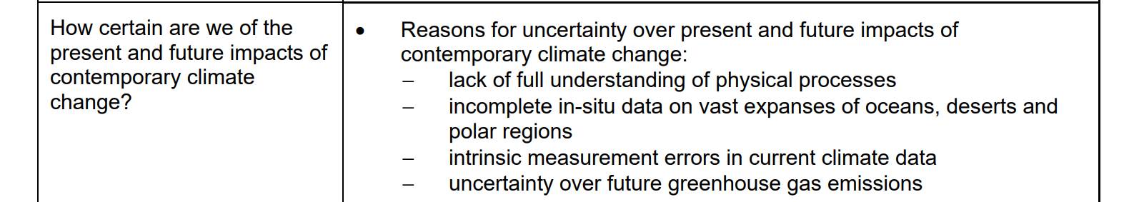 |  |  |  |  | [3]
(d) | Describe the carbon dioxide emission per person shown in Resource 10. |  |  |  | [4]
Indicative content
- High income countries in Resource 10 have higher carbon dioxide emission per person. These include Saudi Arabia, USA, Japan and Germany. The CO2 emission range from as high as 17 units in Saudi Arabia to 8 units in Germany.
- Two of the top countries with the highest CO2 emissions are from the Middle East (Saudi Arabia and Iran)
- The two most populus countries in the world – China and India also appear in the chart. Though having comparable population size, their emissions are vastly different. China at 8 units, comparable to some of the high income countries such as Japan and Germany. Yet, India’s CO2 emission is ony 2 units. All other countries together has CO2 emissions closer to that of India at about 3 units.

Examiners’ comments
- Same issue being repeated here, ie., you are not observing any pattern but merely listing. In this case, do also be reminded that high income countries are not necessarily developed countries. Saudi Arabia is a very good example of a high income countries which may not necessarily have achieved the ‘developed sattus. To be developed, there should be greater income equality.
- Since the population size is given, try to observe a relationship or unrelatedness between population size and emission. Interestingly, there is no relationship. As a larger population may not mean a higher emission level.

(e) | With reference to the Resources 9, 10 and 11, explain why existing climate action by India may not be sufficient to respond to climate change. |  |  | [6]
Indicative content
In a way, this is testing your decision making. You have to decide why India’s existing effort is insufficient and what else can be done.
There are enough evidence to suggest that issues are serious as seen in Resource 9, with the different physical and environmental impacts. Merely relying on rudimentary methods to adapt to climate change will be insufficient in the long run.
Resource 10 shows that India is not the biggest culprit for the CO2 emission, however, it does not mean that India can be complacent, given the severity of the impeding problems seen in Resource 9.
Resource 10 shows that India is already making effort on mitigation by partnering other countries, such as the US, in the climate change efforts. However, the problem can be immediate, and hence needs more immediate action to adapt.
Some others noted that the large population could be a issue for India and there is room to work on decreasing the population to decrease overall CO2 emissions.]
Also, there is a need for more stakeholders to be involved to resolve the problems.

Examiner comments
Many candidates simply pinpoint the issues in the Resources, but made little connection to the question posed.
Others have also considered the effort as ‘insufficent’ because there are many countries which are contributing to the CO2 emissions more than India (as shown in Resource 9). This question is asking about existing action by India!

Section C

Cluster 1 : Sustainable Future and Climate Change

Answer two questions.

4. | “Natural factors do not fully account for contemporary climate change.”  Evaluate the statement. |  | [13]
Indicative content

Natural factors alone do not fully account for contemporary climate change. While Earth's climate has fluctuated over millennia due to volcanic activity, solar radiation, and other natural forces, the rapid warming observed in the last 200 years coincides with the industrial revolution and the dramatic increase in human activities. Carbon dioxide emissions from burning fossil fuels, deforestation, and industrial processes have intensified significantly, leading to higher concentrations of greenhouse gases. These human-induced emissions have directly contributed to the rise in global temperatures. The sharp increase in CO₂ levels parallels the observed warming trend, highlighting human factors as the primary driver of contemporary climate change.

5 | Evaluate the effectiveness of strategies to create liveable cities for women |  | [13]
Indicative content
To evaluate the effectiveness of strategies aimed at creating liveable cities for women, a multifaceted approach is necessary.

First, enhancing urban safety by improving street lighting, ensuring safe public spaces, and strengthening law enforcement has proven effective in reducing fear and fostering greater mobility for women. However, poor urban safety measures may lead to failure of the strategies. While increasing street lighting is often cited as a way to make cities safer, it alone may not suffice. In many cities, well-lit areas continue to see high rates of harassment because there’s inadequate law enforcement or community engagement in safety efforts. Without comprehensive safety planning, fear and danger persist.

Second, equal access to employment and promotions in workplaces leads to financial independence and reduces gender inequality. Implementing gender-responsive urban planning that considers women’s specific needs in transportation, housing, and amenities significantly boosts their quality of life. However, tokenistic workplace policies means that many organizations implement gender equality policies, such as flexible work hours, but they fail if not accompanied by broader cultural shifts. In companies where promotions remain biased or mentorship programs are weak, women still face career stagnation despite the appearance of inclusive policies.

Finally, strategies that alleviate women's domestic burdens—such as promoting shared responsibilities at home and increasing access to affordable childcare—enable women to engage more fully in public and professional life. These strategies, when combined, contribute to a more equitable, safe, and liveable urban environment for women, addressing both their safety and socioeconomic needs. Nonetheless, strategies like offering childcare support often fail when services are either too expensive or located far from where women live or work. This renders the solution ineffective, keeping the burden of household responsibilities on women.

Appropriate examples should be used to illustrate the effectiveness of the strategies – both the pros and cons.

6. | “Successful waste management strategies differ across places.”  Evaluate the statement. |  | [13]
Indicative content
Waste management strategies vary globally due to differences in economic development, waste generation levels, and priorities. High-income and low-income countries need to approach waste management differently to achieve the best outcomes.

1. Waste Disposal (Landfills and Incineration)

High-Income Countries: Given the high waste generation (2 kg/person/day), waste disposal methods such as landfills and incineration have become less favored due to environmental concerns. Green issues such as emissions and land scarcity push for alternative strategies.
Developing Countries: In low-income countries (1 kg/person/day), landfills and incineration are often more viable due to limited infrastructure for advanced waste management. Addressing "brown" issues like sanitation and public health makes these disposal strategies more relevant.

2. Waste Reduction (3Rs and Cyclical Urban Metabolism)

High-income countries are better positioned to adopt advanced waste reduction strategies like recycling, reuse, and urban metabolism, focusing on resource efficiency and sustainability.
In developing countries, infrastructural and economic constraints limit the feasibility of large-scale waste reduction programs.

3. Waste Prevention (Education)

High-income countries can focus on education to reduce waste generation at the source. Waste prevention aligns with the growing emphasis on sustainability and reducing overall waste.
Developing countries may struggle with education and policy implementation on the private sector due to lower public awareness and prioritisation of basic waste disposal over prevention.

Conclusion
Waste management strategies are context-specific. High-income countries should prioritise waste prevention and reduction, while developing countries may find immediate success in improving disposal practices to address basic waste management challenges.

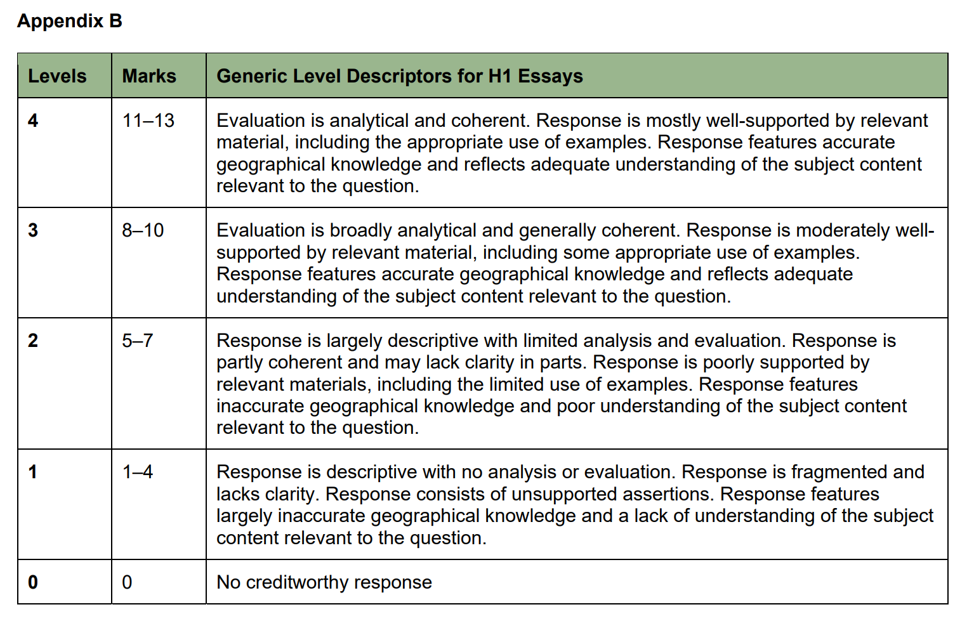

[TOTAL MARKS : 100]

